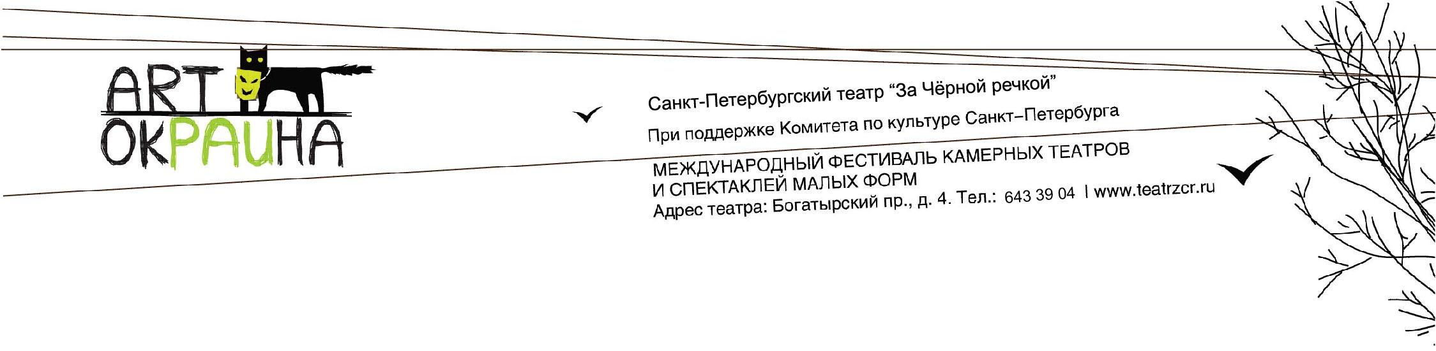

Provisions of the XI international festival of chamber theatres and small scale productions "ArtOkraina"

The festival is held with the support of Culture Committee of the Government of St. Petersburg.

Purposes and objectives
1. Finding new interesting theater groups, talented directors and performers and search of new theater ideas and directions.

2. Drawing attention of the audience, the theater community and the media to chamber performances in Russia and abroad.

3. Possibility of informal communication between participants of the festival and the audience.

4. Development of new theatrical technologies and their application within the chamber stage.

5. Exchange of experience of groups of chamber theaters in Russia and abroad.

Festival program
1. The festival is attended by Russian and foreign theaters with chamber performances created during the theater seasons of 2019-2021.
2. Performances for participation in the festival are selected by the expert Council.
3. The jury of the festival determines the best performers in the following categories:

— Grand Prix;
— Best actor;
— Best actress;
— Best direction;
Nominations can be changed according to the results of the festival.

4. The festival is also expected to hold open thematic discussions with the participation of leading theater critics, cultural figures and representatives of the media.

5. Meetings with the leading masters of the stage are provided as a part of the festival's non-competitive program.

6. The theater groups or its representative should be present either at the closing of the festival.

Terms and conditions of the festival

1. The festival is held from November 12 till November 22, 2021 on the stage of the St. Petersburg Theatre "Za Chornoy Rechkoy".

2. Applications for participation in the festival areaccepted from June 1 till September 1, 2021.

3. Applications are considered by the expert Council of the festival until September 15, 2021.

4. Formation of the festival posters and contracts according to the results of the expert Council is scheduled for the period September 15 till October 1, 2021.

5. The total number of participants in the performance (including administrative and technical staff) should not exceed 8 people.

6. A contract is concluded with theatre companies that have passed the competitive selection.

7. To participate in the festival you need to send a participant application.

8. The organizing Committee of the festival pays for accommodation with Breakfast for each participant during the journey.

9. Payment for transportation of scenery is the responsible of the festival participants.

10. The payment of fee for participants for performances is not provided.

Contact information

Theatre address: 197348, Russia, Saint-Petersburg, Bogatyrskiy prospect, 4
Tel/Fax: (812) 643-39-04
E-mail: festival@teatrzcr.ru
The website of the festival: www.teatrzcr.ru/festival/12

